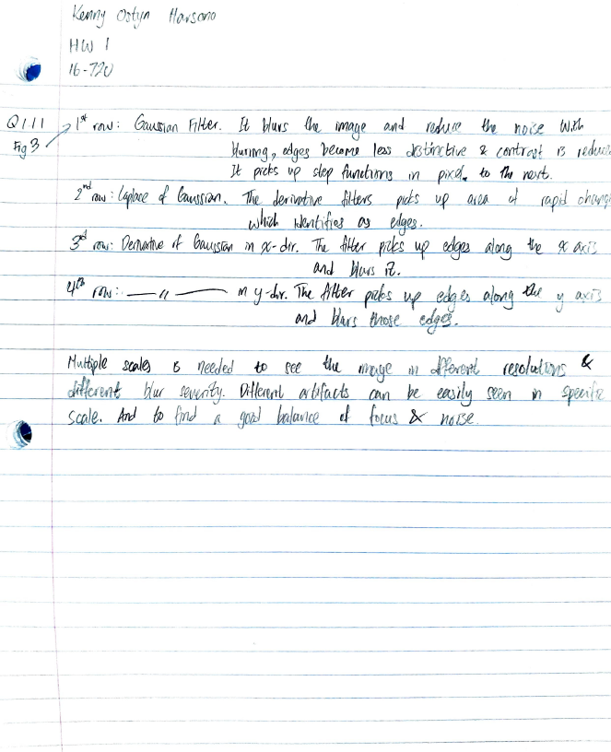

Q 1.1.2: Filter responses visualization

Filter scales = [1, 2, 5, 15]

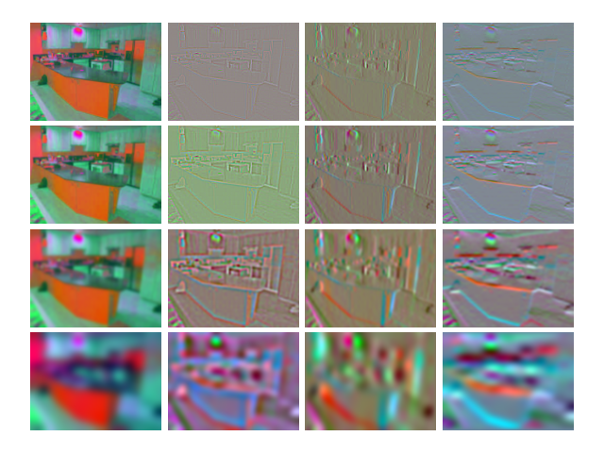

Q 1.3: Wordmaps visualization

K = 10 and other default values

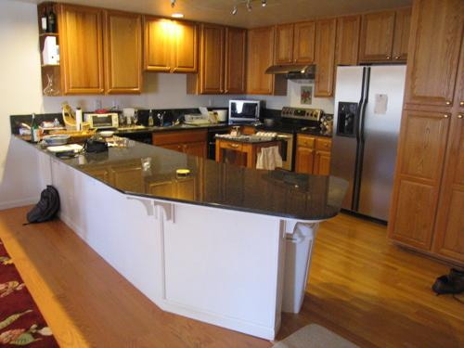

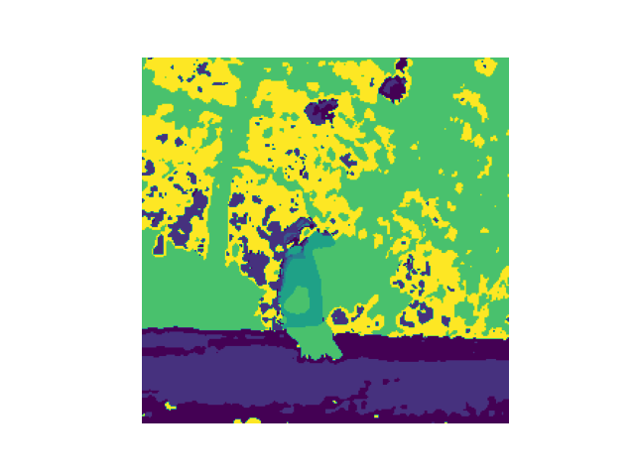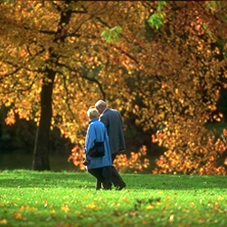

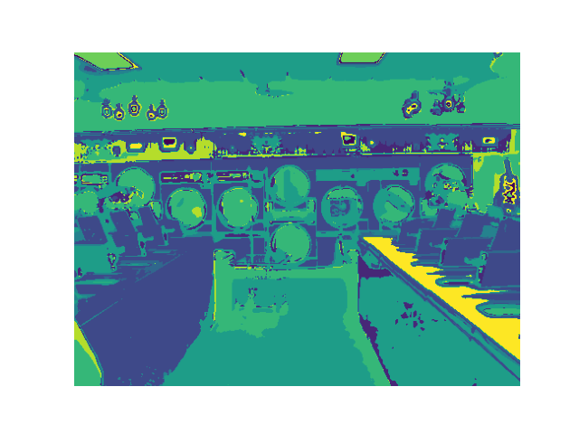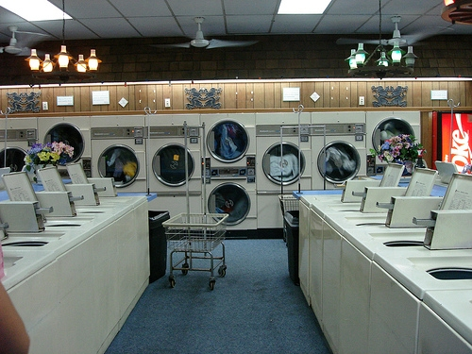

Q 2.5: Confusion matrix & Accuracy

Default values: Filter scale = [1,2]; K = 10; Alpha = 25; L = 1

accuracy : 0.42

confmat:

|  |  |  |  |  |  |  |  |
| --- | --- | --- | --- | --- | --- | --- | --- |
| 26 | 1 | 2 | 3 | 1 | 1 | 11 | 5 |
| 2 | 16 | 2 | 5 | 5 | 8 | 3 | 9 |
| 2 | 4 | 18 | 1 | 4 | 3 | 10 | 8 |
| 2 | 4 | 3 | 26 | 11 | 1 | 3 | 0 |
| 3 | 2 | 1 | 15 | 21 | 3 | 4 | 1 |
| 1 | 0 | 3 | 2 | 9 | 28 | 5 | 2 |
| 10 | 1 | 3 | 2 | 5 | 4 | 20 | 5 |
| 1 | 3 | 13 | 1 | 6 | 6 | 7 | 13 |

Q 2.6: Hard examples

Based on Q 2.5, the two classes that have the most interchangeable results are kitchen and laundromat that have a total of 26 images wrongly labeled. Coming in second place, aquarium & waterfall pairing has a total of 21 interchanged label. Shown below is an example of wrongly labeled laundromat as a kitchen image. This may be the result of the aligned washer looking like a counter table in the kitchen.

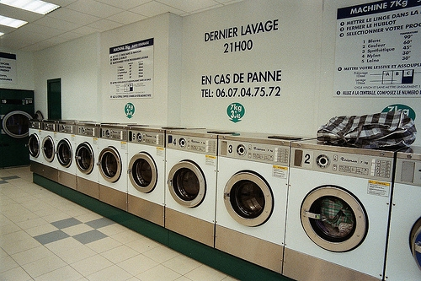

From Q 2.5, it can be said that windmill pictures are the most difficult to classify in comparison with other classes using the bag of words technique. The image below is a windmill image and was labeled desert. This makes sense as the windmill feature is insignificant to the sandy area covering half of the image. In addition, with windmill pictures having various background of sky and greenery, it lead to wrong labels such as aquarium and park respectively.

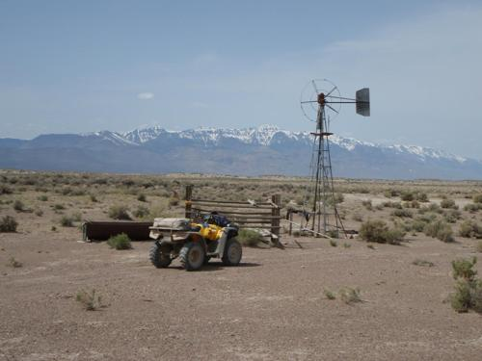

Q 3.1 Fine Tuning

Table 1. Fine tuning experiments

|  |  |  |  |  |  |  |
| --- | --- | --- | --- | --- | --- | --- |
| **Trials** | **Filter_scales** | **K** | **Alpha** | **L** | **Etc Changes** | **Accuracy** |
| 1 | **2** | **10** | **25** | **1** |  | 42 |
| 2 | **4** | 10 | 25 | 1 |  | 41 |
| 3 | **4** | 10 | 25 | **4** |  | 40.3 |
| 4 | 2 | **40** | 25 | 1 |  | 44 |
| 5 | 2 | 10 | **50** | 1 |  | 35.25 |
| 6 | 2 | **100** | **100** | 1 |  | **49** |
| 7 | 2 | **50** | 15 | 1 | Bin Range Change | 39.75 |

Shown in Table 1, there are a total of 6 experiments done with different values in filter scales, K, alpha & layers (pyramid matching). Filter scales and layers don’t seem to add any accuracy in the expense of more processing power and time. Number of words in the dictionary, K, definitely shows the most positive correlation in accuracy. Accuracy jumps as K is increased from 10 to 100. Alpha has a mixed impact on the accuracy. It actually decrease the accuracy when being isolated but increases the accuracy as well when accompanied with high K value.

Q 3.2 Further Improvement

From reading through Piazza, specifying the bin ranges in histogram can help improve the accuracy significantly. However, my experiences stated otherwise. This may be explained through the specified bin ranges to cut off the actual values (removing features).

Also, replacing for loops with built-in numpy functions like broadcasting help a lot with computation speed, cutting the total runtime by about 20%.